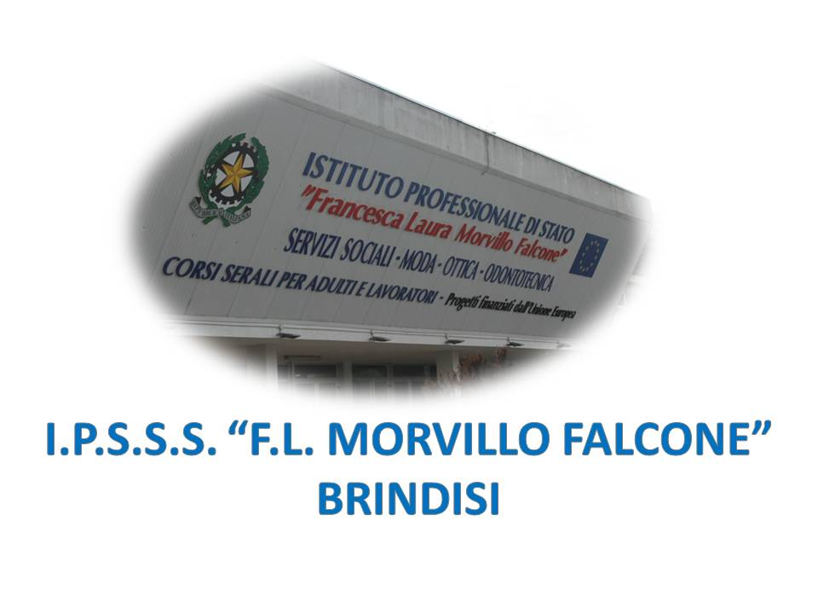

ISTITUTO PROFESSIONALE DI STATO PER I SERVIZI SOCIALI
“Francesca Laura MORVILLO FALCONE”
Via Galanti, 1 - Tel. 0831/513991
brrf010008@istruzione.it – brrf010008@pec.istruzione.it
www.morvillofalconebrindisi.edu.it
72100 B R I N D I S I

MATERIA: Lingua Inglese (ore settimanali: 2).
CLASSE: 3B PD (Serale)
ANNO SCOLASTICO: 2021/2022
DOCENTE: MATTIA ARNESANO

Libro di testo:
GROWING INTO OLD AGE – Skills and Competencies for Social Services Careers
Autori: Patrizia Revellino, Giovanna Schinardi, Emilie Tellier
Edizione CLITT

Argomenti di microlingua:

Unit 1
Growing old – Healthy Aging
- When does old age begin?
- Staying healthy as you age
- Tips for keeping the mind sharp
- A balanced nutrition
- Menopause

Unit 2
Growing old – Minor Problem of Old Age
- Depression and illness in older adults and the elderly (Dementia vs. depression in the elderly)
- Age-related memory loss (Normal memory loss vs. dementia)
- How aging affects the skin
- Aging changes in the bones muscles and joints

Unit 3
Growing old –Major Diseases
- Alzheimer’s disease
- Parkinson’s disease
- Cardiovascular disease

Unit 4
Care settings
- Independent living retirement community
- Assisted living facilities
- Nursing homes

Unit 5
Severe Disabilities
- Down Syndrome
- Autism
- Epilepsy
Language points to remember
- Past simple and Past continuous
- Passive form

Il docente
_______________________

