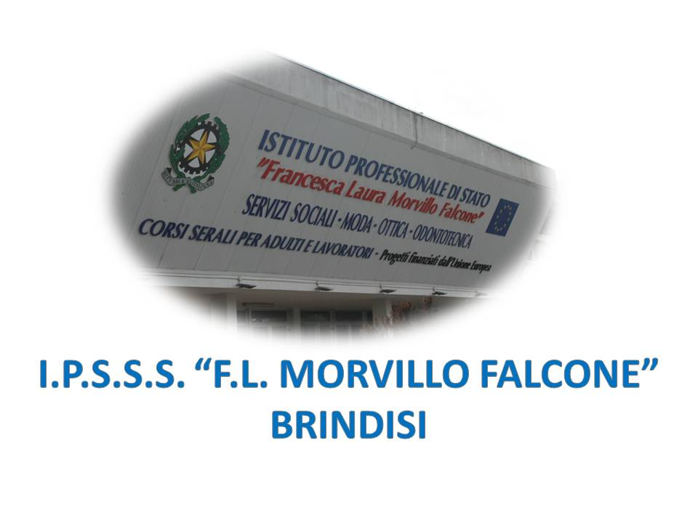

ISTITUTO PROFESSIONALE DI STATO PER I SERVIZI SOCIALI
“Francesca Laura MORVILLO FALCONE”
Via Galanti, 1 - Tel. 0831/513991
brrf010008@istruzione.it – brrf010008@pec.istruzione.it
www.morvillofalconebrindisi.edu.it
72100 B R I N D I S I

MATERIA: INGLESE (ore settimanali: 3).
CLASSE: 5 A PTS
ANNO SCOLASTICO: 2021/2022
DOCENTE: SERRATI’ NICOLA

Libro di testo:

C. ODDONE, E. CRISTOFANI: NEW FASHIONABLE ENGLISH, SANMARCO EDITRICE

Argomenti:

Fashion Trends in recent Time
The 1950s: teenagers as a Market Force
The Fabulous 1960s
1970s trends: Disco Fashion versus Punk Fashion
The Conservative 1980s
The 1990s: between minimalism and body Decorations
Fashion in the new millennium
When shopping becomes an Addiction
A Contemporary Phenomenon: Ethical Fashion
Fashion Merchandizer
Market Research, Promotion, Media: the key to success
Promoting Fashion
Advertising
Globalisation and Fashion
Fashion Magazines
Websites and blogs
The devil wears Prada
Celebrities and Endorsers
Fast Fashion and Low-Cost Brands
Fashion Journalist
Fashion Shows and Brands
Giorgio Armani
Gucci
Fendi
Coco Chanel
Calvin Klein

BRINDISI, lì 30.05.2022
Il docente

Prof. Nicola SERRATI’

