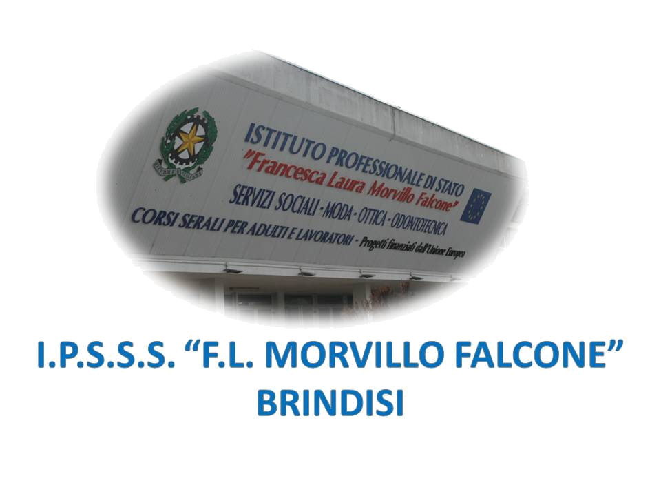
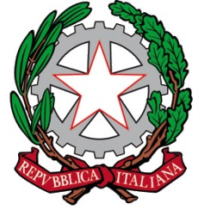


ISTITUTO PROFESSIONALE DI STATO PER I SERVIZI SOCIALI
“Francesca Laura MORVILLO FALCONE”
Via Galanti, 1 - Tel. 0831/513991
brrf010008@istruzione.it – brrf010008@pec.istruzione.it
www.morvillofalconebrindisi.edu.it
72100 B R I N D I S I

MATERIA: LINGUA INGLESE
LIBRI DI TESTO: P. REVELLINO, G. SCHINARDI, E. TELLIER “GROWING INTO OLD AGE”

MODULE 1 - UNIT 3: THE ENVIRONMENT
- Pollution
- Types of pollution
- The hozone hole
- Greenpeace

MODULE 2 – UNIT 3: CHILDREN COMMON DISEASES
- Common diseases
- Childhood contagious diseases
- What are lice?

MODULE 3 – UNIT 1
- Sigmund Freud
- Defence mechanisms
- Psychosexual stages
- Oedipus/Electra complex
- Jean Piaget
- Assimilation and accomodation
- Stages of development
- Erik Erikson
- Psychosocial stages
- Howard Gardner

GLI ALUNNI LA DOCENTE

