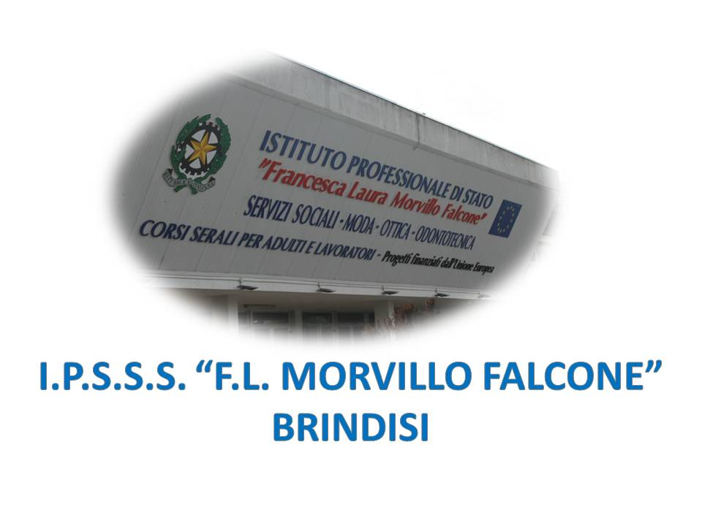

ISTITUTO PROFESSIONALE DI STATO PER I SERVIZI SOCIALI
“Francesca Laura MORVILLO FALCONE”
Via Galanti, 1 - Tel. 0831/513991
brrf010008@istruzione.it – brrf010008@pec.istruzione.it
www.morvillofalconebrindisi.edu.it
72100 B R I N D I S I

MATERIA: INGLESE (ore settimanali: 2).
CLASSE: 4ASS
ANNO SCOLASTICO: 2021/2022
DOCENTE: MATTIA ARNESANO

Libri di testo:

Growing into old age – Revellino, Schilardi, Tellier – CLITT

Argomenti di microlingua:

Unit 1
Psychological Development Theories
- Sigmund Freud (Biography, The unconscious mind; Oedipus/Electra complex; Dream analysis)

Unit 2
Adolescence
- What is adolescence
- Peer relationships
- Risky behaviour: why teenagers do it
- What is cyberbullying?

Unità 3
Addictions
- Focus on drugs
- Alcohol addiction
- Young people and tobacco
- Sexually transmitted diseases

Unità 3
Eating Disorders
- What are eating disorders?
- Anorexia nervosa
- Bulimia

Unit 4
Learning disabilities
- What are learning disabilities?
- Dyslexia,
- Dyscalculia,
- Dysgraphia.

Language points to remember

- Be used to + ING form
- Get used to + ING form
- Be allowed to
- How to express contrast

Il docente

