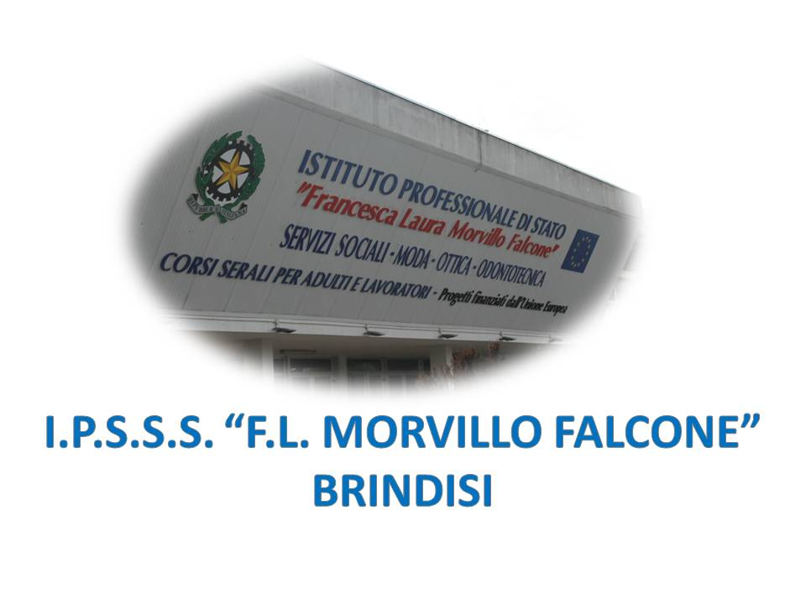

ISTITUTO PROFESSIONALE DI STATO PER I SERVIZI SOCIALI
“Francesca Laura MORVILLO FALCONE”
Via Galanti, 1 - Tel. 0831/513991
brrf010008@istruzione.it – brrf010008@pec.istruzione.it
www.morvillofalconebrindisi.edu.it
72100 B R I N D I S I

MATERIA: INGLESE (ore settimanali: 2).
CLASSE: 4BOT
ANNO SCOLASTICO: 2021/2022
DOCENTE: ROBERTA DE VENTURA

Libro di testo:

Basic English for Opticians

Argomenti:

- Patholoy: Visual disturbances and focusing impairment; Eye diseases;
- Eye specialists: Diffefrent types of eye carebprofessionals: Ophthalmology, Optometry, Orthoptics, Optics;
- An eye specialist’s study;
- At the optometrist’s;
- Eyeglasses: Some historical hints; Benjamin Franklin; Lenses; Eyeglass materials; Frames.
- Contact lenses: Contact lenses; Breathable contact lenses; Coloured contact lenses; Patient instructions: how to insert and remove.

Grammar:

Comparatives and Superlatives.
- Future tenses: Will/Be going to/ P. Continuous.
- Present Perfect, duration form, If clauses, passive form, phrasal verbs.

