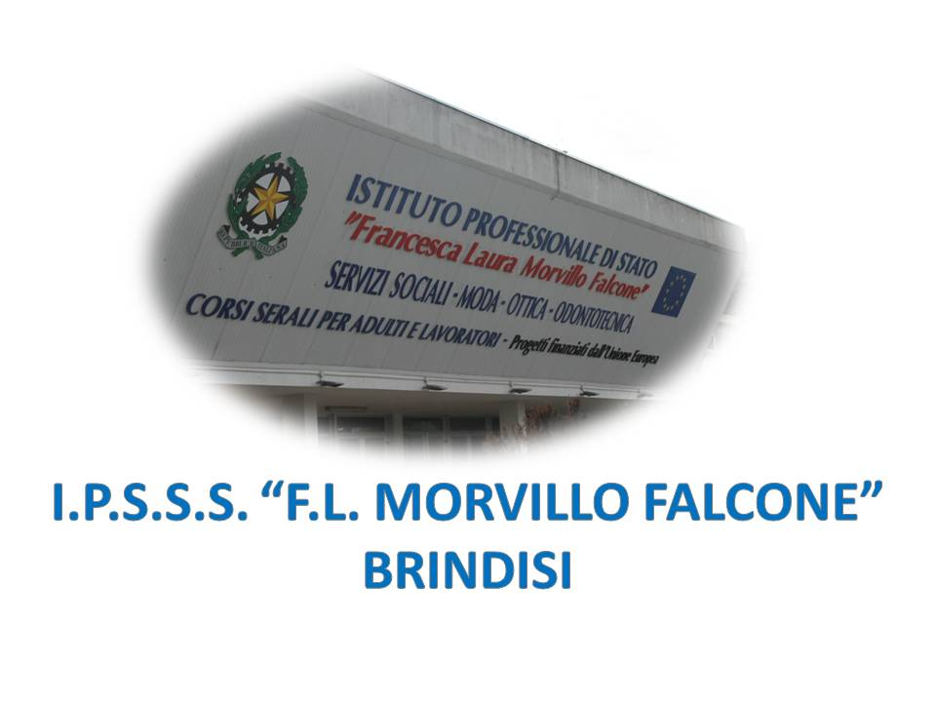

ISTITUTO PROFESSIONALE DI STATO PER I SERVIZI SOCIALI
“Francesca Laura MORVILLO FALCONE”
Via Galanti, 1 - Tel. 0831/513991
brrf010008@istruzione.it – brrf010008@pec.istruzione.it
www.morvillofalconebrindisi.edu.it
72100 B R I N D I S I

MATERIA: INGLESE (ore settimanali: 2).
CLASSE: 3ASS
ANNO SCOLASTICO: 2021/22
DOCENTE: ARNESANO MATTIA

Libri di testo:

Growing into old age – Revellino, Schilardi, Tellier – CLITT

Argomenti:

Argomenti di microlingua:

Unit 1
The Human Body
- The external parts of the human body
- The inside of the human body
- Body system (The respiratory system; The digestive system)

Unit 2
Nutrition
- Food balance
- Five food groups
- The Mediterranean diet
- Ten easy ways to improve your diet

Unit 3
Infant Development
- Birth to three months
- From four to seven months
- From eight to twelve months
- The second year
- The third year

Unit 4
Child Nutrition
- Good nutrition
- Breastfeeding

Unit 5
Education Systems and Childcare Options
- School system in Great Britain and USA
- Childcare options (nursery, pre-school, playground)

Language points to remember

- Past simple
- Present perfect
- Have to/don’t have to
- Must/Mustn’t
- Future simple – will (for predictions)

Il docente

