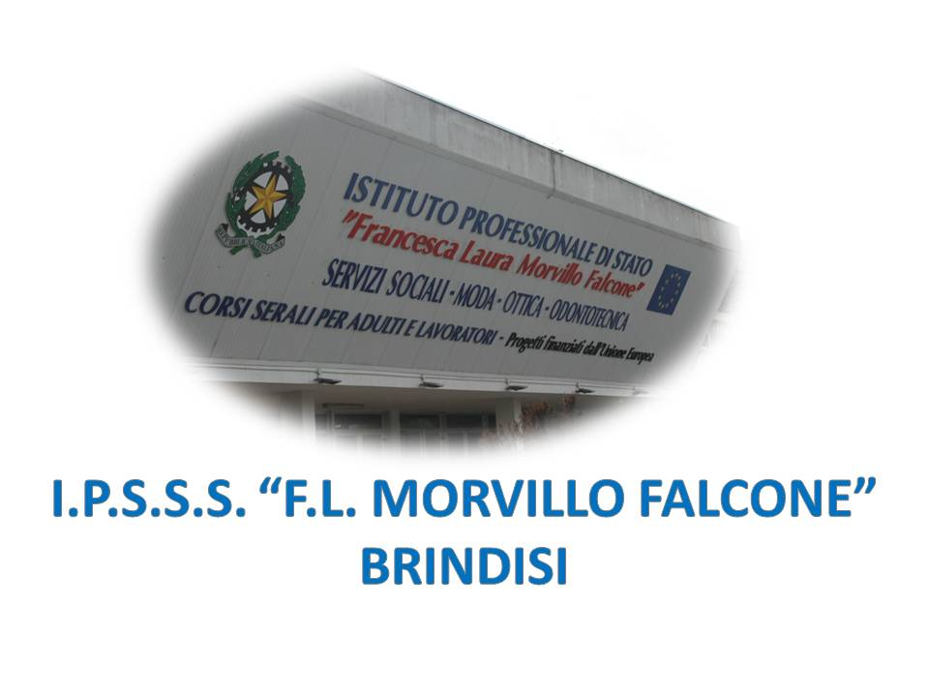

ISTITUTO PROFESSIONALE DI STATO PER I SERVIZI SOCIALI
“Francesca Laura MORVILLO FALCONE”
Via Galanti, 1 - Tel. 0831/513991
brrf010008@istruzione.it – brrf010008@pec.istruzione.it
www.morvillofalconebrindisi.edu.it
72100 B R I N D I S I

MATERIA: INGLESE (ore settimanali: 3). CLASSE: 2 B PIA ANNO SCOLASTICO: 2021/2022
DOCENTE: SERRATI’ NICOLA

Argomenti:

Unit N .1  YOU ARE WHAT YOU EAT  VOLUME 1 | Giving instructions  Asking and saying prices  Ordering food - Countable and uncountable nouns, How much...?, How many...? some, any, no a lot of/lots of, much/many, a little/ a few too much/too many, too little, (not), enough, would like.

Unit N .2  LOOKING GOOD | Speaking on the phone . look, look like, be like, Present continuous, Present simple vs present continuous, Present continuous: future.

Unit N .3  LOOKING GOOD | Speaking on the phone . look, look like, be like, Present continuous, Present simple vs present continuous, Present continuous: future.

Unit N .4  WORLD FAMOUS | Giving opinions - Past simple: verb be Past simple: positive (regular verbs) Past simple: positive (irregular verbs) (1) Past simple: negative, questions and short answers, Defining relative clauses (1): subject.
Unit N .5  GET UP AND GO | Giving directions - Past simple: irregular verbs (2), Prepositions of place, Prepositions of movement, Subject/object questions, How far...?, How long...?

Brindisi, lì 30.05.2022

Il docente

Prof. Nicola SERRATI’

